**IFT 166 Introduction to Internet Networking**

**Lab 24  
Wireless Networking**

**After you complete each step, put an ‘x’ in the completed box**

**Objective**Configure a Linksys wireless router, allowing remote access to wireless clients and connectivity with WPA security.

1. Setup the following topology in packet tracer

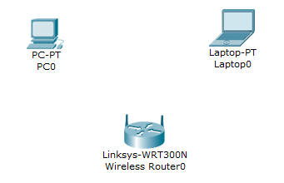

1. Connect PC0 to the Wireless Router via the Ethernet ports

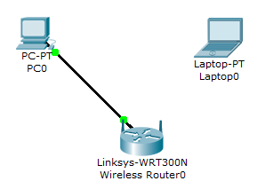

1. After the connection turns green, check the IP address settings. DHCP will automatically be enabled and there should be IP configuration details. If not, check DHCP for address.
2. Ping the default gateway of the router.



1. To access the Linksys GUI Interface, open the web browser on the PC and type in the default gateway address in the URL field.

Enter admin as the default username and password to access the Linksys router.  
(admin in both boxes)

1. Configure the router for Internet connectivity (Internet facing interface) even though there will be no Internet connectivity. For the Internet connection type, choose Static IP and enter the following static IP information.

* Internet IP Address: 198.133.219.1
* SM: 255.255.255.0
* DG: 198.133.219.254
* DNS 1: 198.133.219.10

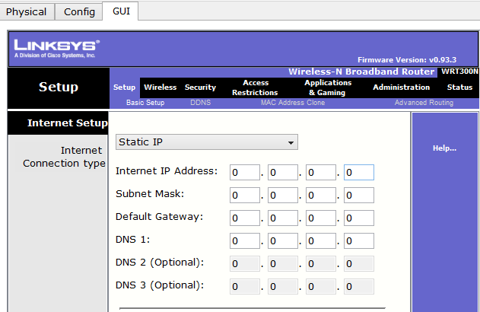

1. Configure the inside network parameters. Scroll down to the network setup and enter the following information

* IP Address: 172.31.1.1
* SM: 255.255.255.224
* Staring IP Address: 100 (leave as it is)
* Maximum number of users: 25

1. Save the settings and close out of Linksys router



1. Return to the command prompt of Host-A. Enter the command ipconfig /release to release the IP address and then ipconfig /renew to get a new IP address

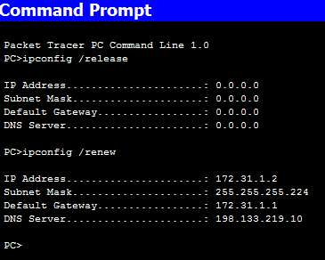



1. Configure wireless connectivity for wireless devices

* Set the network mode for Wireless-N Only.
* Change the SSID to MyHomeNetwork
* For best performance in a network using Wireless-N, set the radio band to Wide-40MHz.
* Click Save Settings

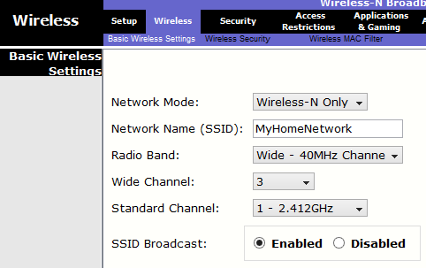



1. Configure wireless security so that clients must authenticate to connect to the wireless network

* Click the Wireless Security option under the Wireless tab.
* Set the Security Mode to WPA2 Personal.
* Leave the encryption mode to AES and set the passphrase to mysecret.
* Click Save Settings

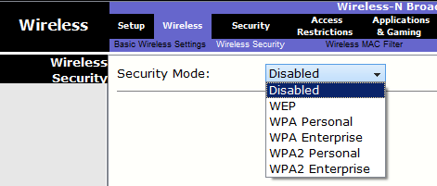

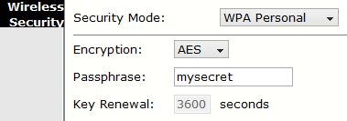



1. Configure Laptop to access the wireless network.
2. 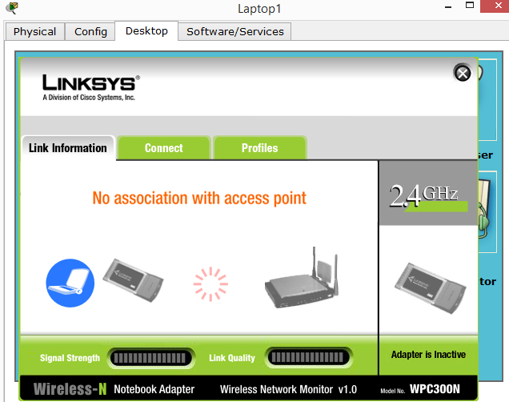Click Laptop and click Desktop > PC Wireless. The window that opens in the client Linksys GUI. You may need to add a wireless module to the laptop.



1. Click the Connect tab and click Refresh, if necessary. You should see MyHomeNetwork listed under Wireless Network Name.

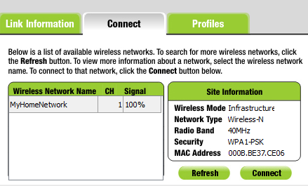

1. Click MyHomeNetwork and click Connect.

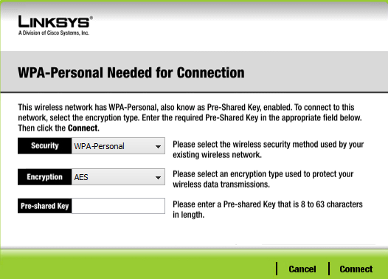

1. The Pre-shared Key is the password you configured earlier i.e. mysecret. Enter the password and click Connect.

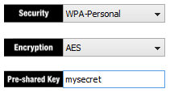



.

1. Close the Linksys GUI and click Command Prompt. Enter the command ipconfig to verify Laptop received IP addressing.

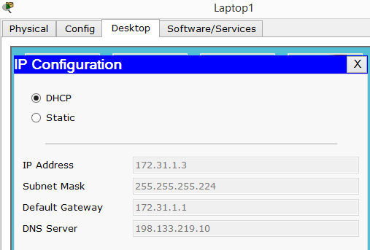

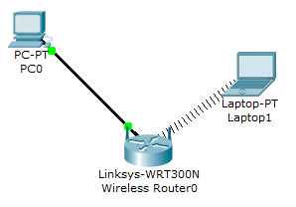

1. Verify connectivity between Laptop and Host-A.

* Ping the Linksys router from the Laptop.
* Ping Host-A from the Laptop.

